DOCUMENTATION ON ECS MICROSERVICES(Terraform)

In this documentation, we have to make 6 microservices in a single cluster using ECS, it will have 6 pipeline for 6 microservices. And also , we will use one loadbalancer for handling all the microservices and will apply Autoscaling as well.

What is Microservices?
Microservices are an architectural and organizational approach to software development where software is composed of small independent services that communicate over well-defined APIs. These services are owned by small, self-contained teams.
Microservices architectures make applications easier to scale and faster to develop, enabling innovation and accelerating time-to-market for new features.

The infrastructure that we are going to build is composed of the 6 microservices:
1. Service A
2. Service B
3. Service C
4. Service D
5. Service E
6. Service F
We are going to use ECS for container and will deploy all of our microservices in a single cluster. We will have 6 pipelines, one for each responsible for building, testing and microservice, and each pipeline will be deploying the respective microservice.

So there are following steps that we have to followed for this infrastructure:

1. Create a VPC with subnets and also required IAM roles.

2. Create an ECS cluster in one of the public subnets & ECR for Docker images.

3. Create an ELB in one of the public subnets.

4. Configure the ELB with a Target Group for each of the 6 microservices.

5. Create a Task Definition for each of the 6 microservices.

6. Create a Service for each of the 6 microservices, associating it with the
appropriate Target Group.

What is Terraform?
Terraform is an infrastructure as code (IaC) tool that allows you to build, change, and version infrastructure safely and efficiently. This includes low-level components such as compute instances, storage, and networking, as well as high-level components such as DNS entries, SaaS features, etc. Terraform can manage both existing service providers and custom in-house solutions.
Let’s have a look for script

Creating VPC, Subnets, Internet Gateway
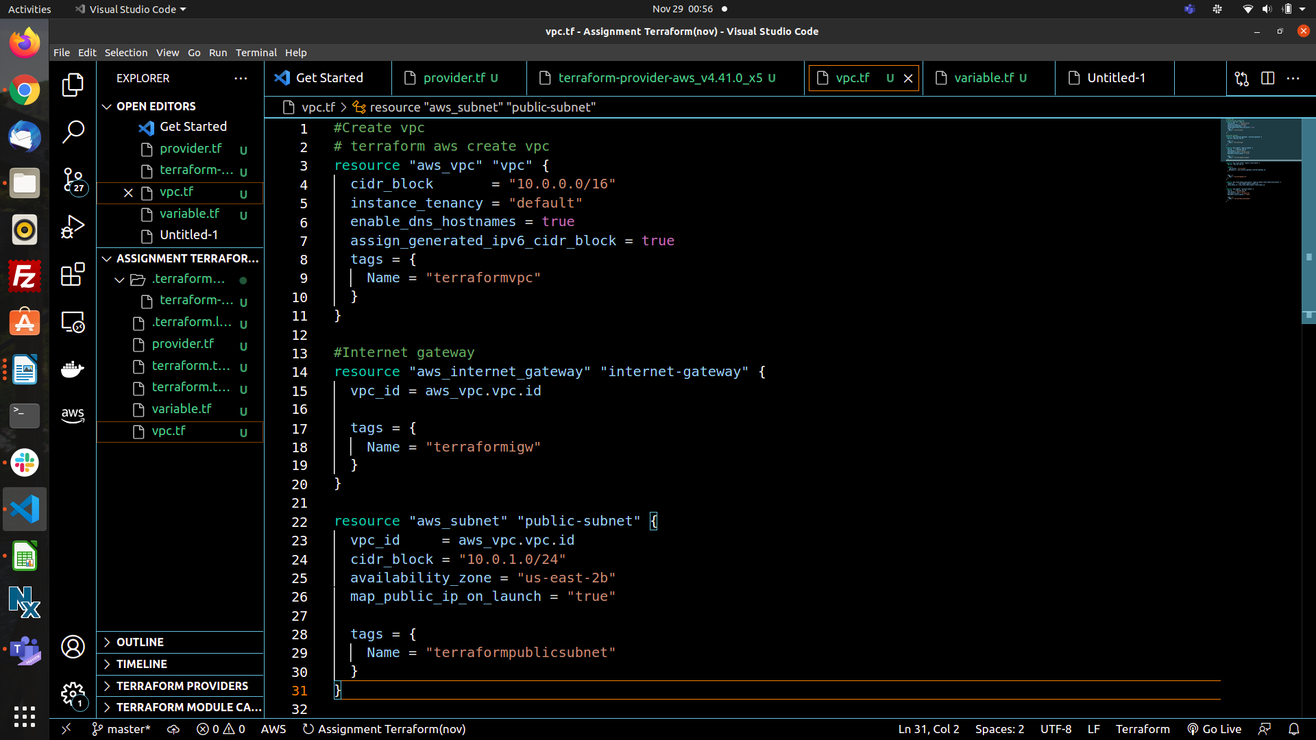

In the next steps we’ll go for ECR and ECS:

ECR (Elastic Container Registry)
ECR is a Docker container registry which is easier to store, share and deploy container images.

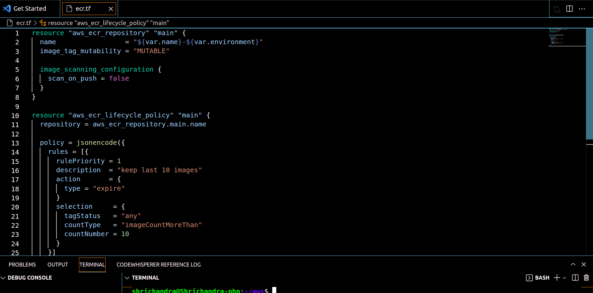

ECS (Elastic Container Service)
Now that ECR is defined and ready for image of container, its time we setup ECS cluster.
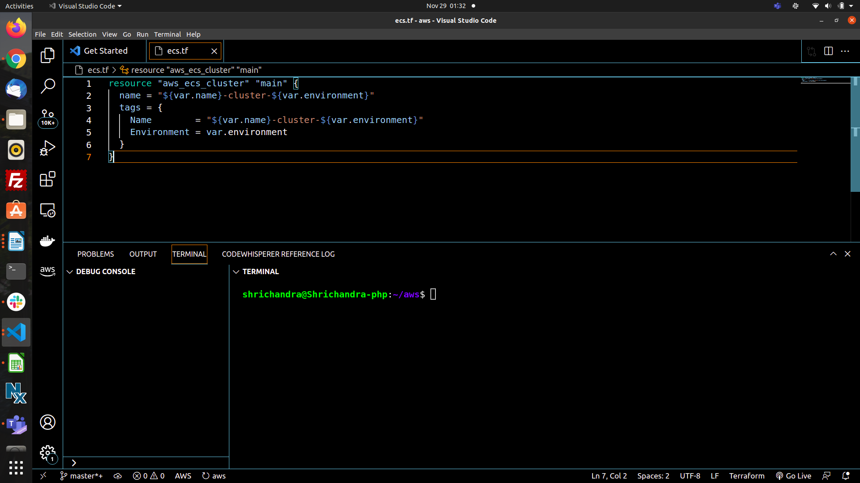

What are the AWS CI/CD Tools?
AWS CodeCommit: Managed Repository Services (Source)

AWS CodeBuild: Container-based Serverless Build tool/Service (Build)

AWS CodeDeploy: Deployment service

AWS CodePipeline: Workflow management e.g. Source ,Build, Deploy

Terraform Instructions:
First make sure AWS CLI is installed and you have configured authorization properly After that: Initialize Terraform from the terraform folder:
Run these Commands:
Terraform init
After initialization done, changes variable values you will find in variables.tf

variables.tf
After done with changing variables/parameters, and all set, it's time to do a to see/verify what resources this will create

Terraform plan
Verify once and if all seems well, it's time to create actual remote infratucture in AWS

Terraform apply

So, this is how we created infrastructure for this Projrct.

